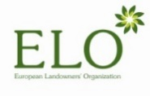

DRAFT AGENDA
23 November 2020 – 9:30 a.m. – 12:00 p.m.
via KUDO
- 09h30 – 09h40: Sound check
- 09h40 – 10h15: The new EU Forest Strategy
- 10h15 – 10h45: Implementation of the EU Biodiversity Strategy for 2030: Working Group “Forests and Nature”
- 10h45 – 11h05: Mapping and Assessment of Ecosystems and their Services report (MAES)
- 11h05 – 11h20: Renewable Energy Directive II – Guidance on sustainable criteria for bioenergy
- 11h20– 11h35: EU 2030 climate target plan: Role of forests
- 11h35 – 11h50: Climate change adaptation strategy
- 11h50 – 12h00: AOB

